[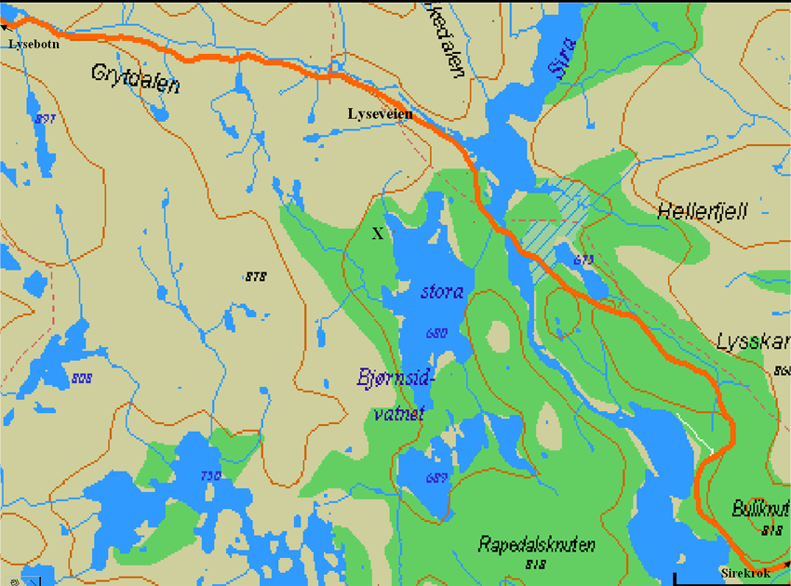](http://www.persett.net/hytte/Bjødnsi-panorama.jpg)